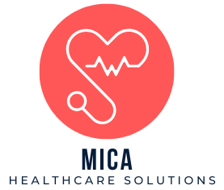

**Appointment Scheduling Report**

**MICA Healthcare Solutions**

**Published Date: 2024-10-13**

**Overview**

|  |  |
| --- | --- |
| **Metric** | **Value** |
| Total Appointments Scheduled | 2,200 |
| Total Completed Appointments | 1,750 |
| Total Canceled Appointments | 300 |
| Total Rescheduled Appointments | 150 |

**Appointment details**

|  |  |  |  |  |
| --- | --- | --- | --- | --- |
| **Date** | **Time Slot** | **Patient Name** | **Contact Info** | **Appointment Type** |
| 2024-7-05 | 12:00 pm | Charles Abraham | 443-711-0010 | New |
| 2024-9-08 | 07:00 am | Solutions Mica | 410-704-4465 | New |
| 2024-10-05 | 09:00 am | Alex Johnson | 443-010-2222 | Follow-up |
| 2024-10-09 | 02:00 pm | Emily White | 410-212-4568 | Follow-up |

**Departmental Summary**

|  |  |  |  |  |
| --- | --- | --- | --- | --- |
| **Department** | **Total** **Appointments** | **Completed** | **Canceled** | **Rescheduled** |
| General Medicine | 800 | 650 | 100 | 52 |
| Pediatrics | 600 | 470 | 90 | 40 |
| Cardiology | 400 | 350 | 30 | 20 |
| Orthopedics | 400 | 280 | 80 | 10 |

MICA Healthcare Solutions

8000 York Rd, Towson, MD, 21252

(410)-704-XXXX

XXXXX@Healthcare.solutions